lune valley dtc
CHEWING
Puppies need to chew in order to relieve the pressure on their gums as their new teeth set in at around 18 – 24 weeks. To avoid the chewing being aimed at your house and possessions follow the guidelines below.
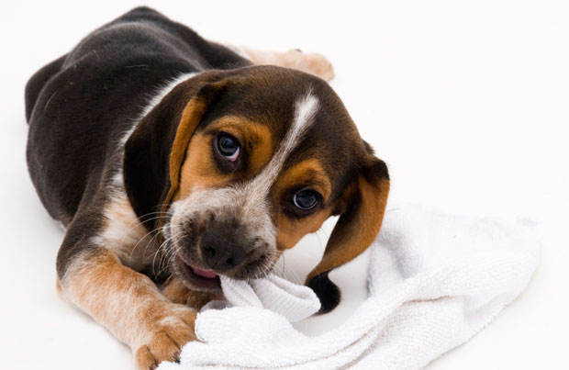
- Puppy proof the house! Don’t leave valuables where puppy can get his paws on them.
- Provide plenty of toys and objects to chew.
- Use safe chews like Kong toys and Nylabones.
- Cool or freeze the toys to help soothe sore gums
If you have a puppy or older dog that only chews things while you are out, boredom, frustration or anxiety may be the cause.
Preventing Boredom Chewing
If your dog is bored while you are out or busy it probably means that he needs more mental and physical exercise.
- Adult dogs need at least 40 minutes of off lead running each day.
- Play fetch games and tug games on your walks or in the garden.
- Most dogs will not be tired after a quick 15 minute walk, this will often leave them with plenty of pent up energy to chew your sofa with!
- Provide enough mental stimulation so that your dog won’t go ‘self employed’!
- Do some training exercises or teach your dogs tricks.
- Use interactive toys such as Kong toys or Buster Cubes – they are great for mental stimulation while you are either in or out.
If you already provide these stimulants for your dog and your are still getting chewing and destructive behaviour, your dog may be experiencing anxiety when left. Please telephone the surgery for more advice or to be put in touch with a behaviour specialist.

