**lune valley dtc**



**PLAY BITING**

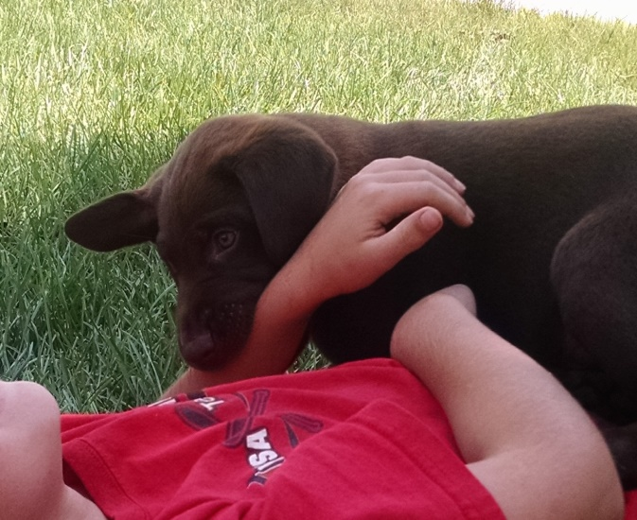

**Puppy teeth – yes indeed they do hurt!**

Puppy biting is a perfectly natural behaviour. Puppies use their mouths to explore their surroundings; nothing is sacred from puppy teeth. They also use their teeth when playing. Fortunately this is something they usually grow out of when they lose their puppy teeth at around sixteen weeks.

Puppies themselves learn that their teeth are sharp when they are still with their mother and littermates. They begin to hurt their mother’s teat when feeding and she will get up and walk away. The pup learns there is a consequence to using teeth. They also learn the consequences of using their teeth too hard when playing with their littermates. If they use their teeth too enthusiastically the game will end one way or another. Either their littermate will yell in pain and stop playing or they may end up fighting.

Remember that dogs only have one defence if they are in pain, frightened or cornered and that is to use teeth. This does not make a bad dog it is simply dog behaviour!

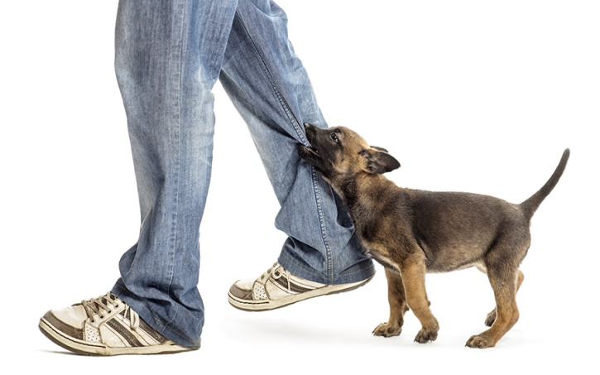

**Your job is**

* to teach the dog that teeth on human skin are not allowed! You also need to teach him to have a soft mouth.
* To help him learn to inhibit his bite you need to act like a playmate.
* Never use your hands or body as a toy when playing with your puppy. Instead use a suitable toy.

If your puppy catches your skin or clothes when you are playing yell ‘ouch’ –a good high pitched yell is needed as though he really hurt you. Get up, move away from your puppy and stop playing. Redirect his teeth onto something more acceptable, a stuffed Kong, the cardboard innards of toilet roll or kitchen roll, a toy or a rawhide chew. (Don’t give your puppy cheap plastic toys to chew, as they can be dangerous if swallowed.)

Many puppies under 14 weeks will back off when you yell then come back and lick you. Praise and redirect the play onto something appropriate. Some puppies will see the yell as a cue to lunge at you even harder. These puppies are usually over stimulated, over tired or perhaps Terriers! Do not shout, do not use a water pistol, do not scruff or shake, simply remain calm, get up and walk away.

**Puppies will latch onto to anything that moves –your trouser leg, the bottom of your dressing gown and your toes! Why, because it gets a reaction from the owner. If this happens, stop walking. Do not get into a game of tug with your trouser leg or dressing gown. Try and redirect your puppy onto something more acceptable.**

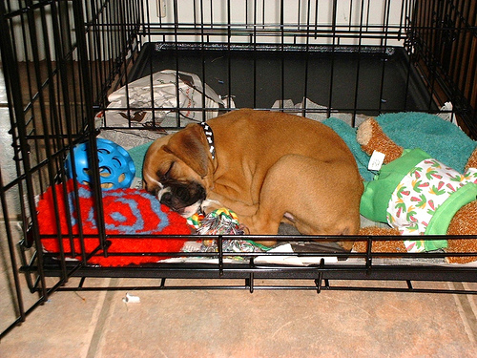 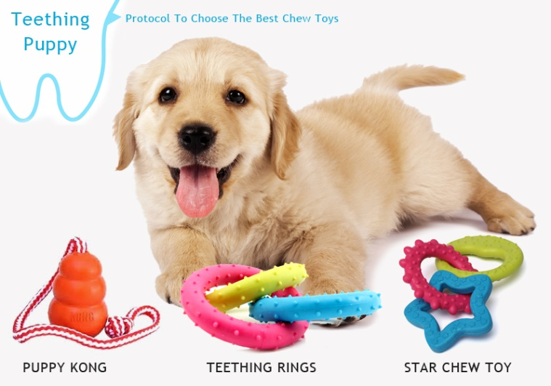

Insure your puppy is getting enough rest during the day –especially if you have children. Place your puppy on a good diet as some diets have been implicated in effecting behaviour. Make sure that everyone in the household treats your puppy the same way.

Children should always be supervised when they interact with your puppy, as young children tend to flap their arms around squealing, which only excites the puppy.

Stopping a puppy play biting takes time and consistency.

Being proactive instead of reactive will safely teach your puppy where and when he can use his teeth.

www.apdt.co.uk