lune valley dtc

CRATES/INDOOR KENNELS
Dog crates are specially designed enclosures that provide temporary security for your pet.
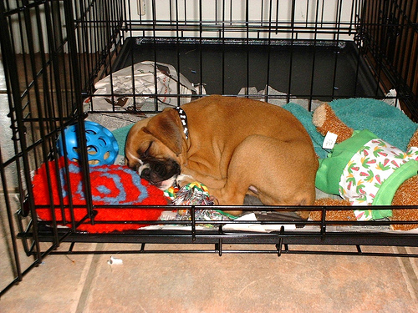
Security is the operative word – people often view crates as cruel or jail-like but in actual fact our furry friends absolutely adore them, it provides them with a secure den like environment where they can feel safe and comfortable. They are perfect for use during house training, for the protection of household items, travelling, illness and general control.
House Training Use of crates while house training your puppy really will speed up the process. The puppy is temporarily confined to his bed, and as it is instinctive for puppies not to soil on their eating/sleeping areas, they learn very quickly how to hold themselves.
Protection Puppies love to chew. On those occasions when you cannot supervise them, confining your puppy to a crate with his own chewable bones and toys will ensure that both he and your home are safe!
Travelling It is important that our dogs are kept safe while we travel. If a dog is loose in the car and free to jump around it can be very distracting and risks injury to itself and you. A crate provides an ideal environment to keep you and your dog secure and safe.

THE CRATE
What Size? The crate should allow your puppy/dog enough room to lie down comfortably with stretchable leg room he should be able to sit or stand up without bumping his head, and be able to turn around easily.
What to Put In It? The contents of the crate are very important. Have only his or her bedding to fill the base of the crate and a water bowl. Bones, chews, |Kongs and toys are good for amusement. Do not put newspaper in the crate. Toileting should only be associated with outside. The idea of the crate is to confine your puppy solely to his sleeping area, which the majority of dogs instinctively do not soil.
Where to Put It? Have the crate in a family location where puppy can still be involved with the rest of the household. Isolating the puppy in another room while you are all in the living room will possibly cause frustration and you puppy will be unlikely to settle.
Ensure that children are aware it is not a playhouse and they should not disturb the dog while he is in there.
HOW TO INTRODUCE THE CRATE
- For the first couple of days allow your puppy to explore the crate on his own. Do not force your puppy to enter. Making nice associations with the crate is the best way to encourage him in. For example feed your puppy his meals in the crate: throw yummy tit bits to the end of the crate or put a filled Kong toy in there.
- Once your puppy is confident entering the crate you can begin to close the door and him in there for short periods. The best time to do this is when he is tired. Provide something positive in the crate such as a Kong. If your puppy is busy enjoying his Kong he is less likely to worry about the door being shut.
- Over time your puppy will get very used to spending longer periods of time in the crate to rest and sleep and you will be able to leave him in there when you are out. Aside from sleeping in it over night the maximum a puppy should be left in a crate is 4 hours. Always make sure they have plenty of drinking water. Before you puppy spends any lengthy period in the crate always ensure he has had exercise and a chance to relieve himself.
- NEVER use the crate as a punishment area. Always, always make nice associations with it.

